**GROUP NO. 12**

**Dr V: Your Vegi Doctor**

**Prakhar Jain(0827CI191044)**

**Sahaj Makwana(0827CI191049)**

**Snehal Singh Solanki(0827CI191056)**

**Abstract**

In this online era, where everyone is using online tools for day-to-day activities, there are many problems that a user/farmer is facing as they have currently slow access over online platform and also have to depended on someone else to control their online tools.

They are currently having slow access to identify/detect the disease in plants that they are growing and don’t know how to cure it, so this project uses mobile/web application which will help user to detect and find the solution for a particular vegetable disease using TensorFlow and CNN model.

Therefore, with the help of this project we will help them to detect the disease in the growing plants and cure in early stages with mobile/web application. It helps the user to facilitate easy searching of plants disease and its cure. While using this app any user can use basic functions such as taking the photo of the growing plants, knowing about its disease, finding its cure etc.

**KEYWORDS**

Potato disease; Disease recognition, Early blight, Late blight, Image segmentation, CNN, TensorFlow

**Problem Statement**

Farmers who grow potatoes suffer from serious financial standpoint losses each year which cause several diseases that affect potato plants. The diseases Early Blight and Late Blight are the most frequent.

**INTRODUCTION**

Agriculture is one of the crucial tools to alleviate poverty and also helps to achieve the economic growth. Insecurity of food can create a huge risk of several malnutrition. Therefore, food production is a powerful component in the whole world. People in rural areas are mostly dependent on agriculture, World Bank reported that approximately 80% people in rural areas are involving in farming [1]. Potato is a highly-successful and most favorite garden vegetable in the world. Actually, it is a widely cultivated October-March winter crop. After rice and wheat, potato is the 3rd most important crop in Bangladesh to enhance economic growth. Bangladesh is the 4th potato-producing country in Asia and hold 7th position throughout the world [2]. However, several diseases attack potato plants during harvesting. Therefore, detecting the conditions of potato fields and taking early treatment according to the results could be a great solution to increase potato production, and that was the aim for doing this study. Several traditional machine learning algorithms already used to classify potato leaf disease. This study for combining segmentation techniques and deep learning algorithms together to improve classification results. Image segmentation to mask the images of the potato leaves can produce a better image dataset. Computerized pictures are transformed into different picture sections using the method of image segmentation. This technique is ordinarily utilized to find objects and boundaries in pictures. It is the method of relegating a name to each pixel in a photo such that pixels with the same name share specific characteristics. However, several algorithms for image segmentation are Otsu’s Binary threshold algorithm, Contour Detection, and K-means clustering Algorithm. K-means algorithm is one of the most popular segmentation algorithms. This algorithm uses different K values and cluster the objects according to closet neighbor where neighbor objects considered based on k value. Euclidean distance used to calculate similarity distance of K-means algorithm. Usually K value varied between 2 to 10 [3]. Different traditional machine learning algorithms was popular to predict plant diseases as well as to perform several computer vision tasks. For example, Md. Asif Iqbal and Kamrul Hasan Talukder proposed a model where they applied seven popular traditional machine learning algorithms. In this study they also used image segmentation techniques on 450 images collected from PlantVillage dataset. Among seven algorithms random forest provided 97% accuracy as the best model [4].

Another relevant work by Chaojun Hou et al. reported several machine learning algorithms and used graph cut segmentation techniques to predict early and late blight diseases on potato leaf. After image segmentation, they achieved 91% accuracy from SVM classifier [5]. However, deep learning algorithms are now appropriate to improve performance accuracy. Several deep learning algorithms are available to complete different experiments on different agricultural yields, such as rice, tomato, bell pepper, potato [6]. Along with these algorithms, image segmentation techniques also help to achieve most prominent result. Therefore, in this study image segmentation techniques and deep learning algorithms used together to predict potato leaf disease with an enhanced performance results.

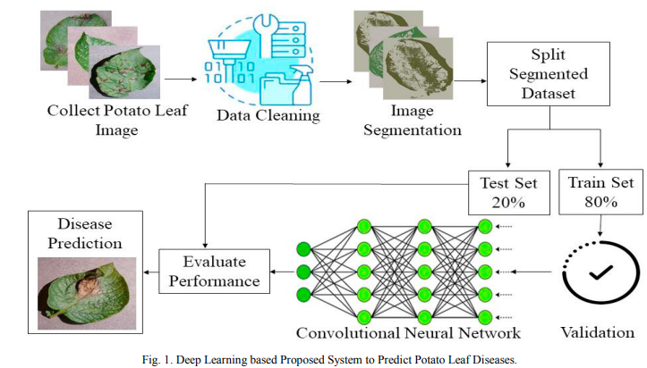

**Literature Review**

Several research has done on agricultural development. It can enhance economic growth as well as can provide a healthy environment for human beings. To increase crop production speed already deep learning model and computer vision-based studies have been got huge attention. In this section, an impressive summary is presented to know about previous research work.

In a research paper titled “Krishi Mitra: Using Machine Learning to Identify Diseases in plants”. Here they used TensorFlow Framework by CNN model methodology to implement their project. The advantage of this model was that only leaf area was calculated and fungi caused diseases in sugarcane can be recognized. The disadvantage of was that High Computational Complexity was required to implement it.

In a research paper titled “Severity Identification of Potato Late Blight Disease from Crop Images Captured under Uncontrolled Environment”. Researchers used Fuzzy c-mean clustering, Neural Network in implementing the model. Does not need special training to farmers as dataset has images in different angles was the main advantage of the model. The only disadvantage was that the images captured by untrained farmers were not oriented and contain cluster of leaves with background visible in several segments.

In a research paper titled “Potato Disease Detection Using Machine Learning”. Image processing was the used technology over here. Use of CNN Model gained 90% validation accuracy was the major pro in this project. Large Training Model Is Required was the major drawback of this model.

**Methodology**

**Data Collection**

Models are trained and assessed on a specific dataset to produce an accurate leaf classification and disease diagnosis algorithm. In this paper, two distinct datasets such as PlantVillage and Mendeley, and three classes are gathered. Early and late blight are two frequent potato diseases; however, we also included healthy leaf as a class in the total three classes. The dataset has been divided into 80:20 ratios for models train and test purpose that provided the decent performance of our proposed network. The dataset used in this project are the pictures of potato leaf divided into three categories:- The healthy leaves, the early blight and the late blight. The dataset was taken from Kaggle website under the name “PlantVillage Dataset”.

|  |  |
| --- | --- |
| **Samples** | **Number** |
| Healthy leaf | 152 |
| Early blight | 1000 |
| Late blight | 1000 |
| **Total** | 2152 |

**Augmentation**

Data augmentation is a powerful method for increasing the accuracy of modern image classifiers [23]. We applied several augmentation techniques to the raw dataset to improve our model performance and recognition capability. On training images with one axis fixed and the other stretched to a predetermined angle, a shear range of 0.2 is applied. Shear refers to an axis-based distortion of the image, usually done to produce or correct the perception angles. Typically, it is utilized to enhance photos so that computers may observe how humans perceive things from various perspectives. Zooming was done with a 0.2x range, and the raw images were rotated horizontally with a horizontal flip. The augmentation methods that we used in this research are listed below and depicted in Fig 3. A total of 10320 images were generated after data augmentation where 8256 and 2064 data were considered for training and testing the model.

**Classification**

After the above processes, further we need to classify images using Convolutional Neural Network (CNN) architecture. CNN is a supervised learning method where identification of image by training existing dataset and targeting image variables. The convolutional layer in CNN helps neural network to recognize potato leaves based on the attributes that they have. Neural network uses pixels in the picture to recognize images of potato leaves. In this project we will be using image with size 150X150X3; where it will have three channels, that are red, green and blue. The leaf image will be convoluted with a filter firstly. Then pooling will be applied to reduce the resolution of the image with keeping its quality intact. MaxPooling will be used on output image. In the next step, this layer us being flattened. This will change the feature map resulting from pooling into vector form. This project has the proposed model for CNN architecture in identifying diseases in potato leaves using 4 convolutional layers and 4 MaxPooling



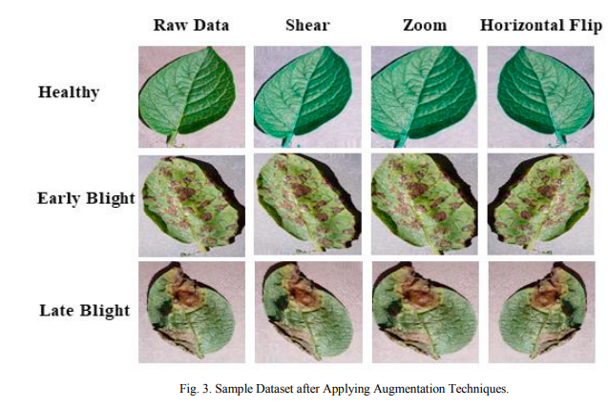

**MOTIVATION**

1. It is very difficult for farmers to identify various disease in plants.
2. The estimated annual crop losses due to plant disease at world wide is $60 Billions.
3. The traditional tools and techniques are not useful since it takes up lots of time and manual work
4. However with the help of disease detection these difficulties will no longer prevent.

**Technology Used**

A) Model Building :TensorFlow and CNN.

B) Backend : tensorflow serving.

C) Frontend: React JavaScript .

**Conclusion**

In this project, with the help of deep learning techniques and convolution neural network classification based approach is proposed to detect the late blight, early blight and healthy leaf images of potato plant. We found that CNN is the best way to perform this type of classification object. This model gains 91.41% of validation accuracy. We think this type of project will play a vital role in our agriculture sector. Most of the farmers of the village in India are not literate and they don’t know about the disease properly. We think that, this work can change the situation of the potato grower in India. The experiments have been carried out on healthy and diseased leaf images to perform classification. It is concluded that the proposed method effectively recognizes three different types of potato leaf diseases. We applied a k-means clustering segmentation approach for three different values. Prepared dataset using three augmentation techniques

**Acknowledgment**

We would like to thank our guide Dr. Praveen Gupta Sir for their guidance and feedback during the course of the project.

**References**

[1] Nugroho N. Sunjoyo (2022) “Agriculture and Food.” https://www.worldbank.org/en/topic/agriculture. Accessed 11 Aug. 2022.

[2] Bangladesh - Potatoes Production. https://www.nationmaster.com/nmx/timeseries/bangladesh-potatoes-production-fao. Accessed 24 Jun. 2022.

[3] Zheng, Xin, et al. (2018) “Image segmentation based on adaptive K-means algorithm.” EURASIP Journal on Image and Video Processing 2018.1: 1-10.

[4] Iqbal, Md Asif, and Kamrul Hasan Talukder. (2020) “Detection of potato disease using image segmentation and machine learning.” International Conference on Wireless Communications Signal Processing and Networking (WiSPNET). IEEE.

[5] Hou, Chaojun, et al. (2021) “Recognition of early blight and late blight diseases on potato leaves based on graph cut segmentation.” Journal of Agriculture and Food Research 5: 100154.

[6] Lamba, Monika, Gigras, Yogita and Dhull, Anuradha. (2021) “Classification of plant diseases using machine and deep learning.” Open Computer Science, vol. 11, no. 1, pp. 491-508. https://doi.org/10.1515/comp-2020-0122.